Problem Statement:

Consider yourself to be Sam who is a student at a prestigious university. You have enrolled for the SQL course and it is your first semester.

Tasks To Be Performed:

1. Install MS SQL Server

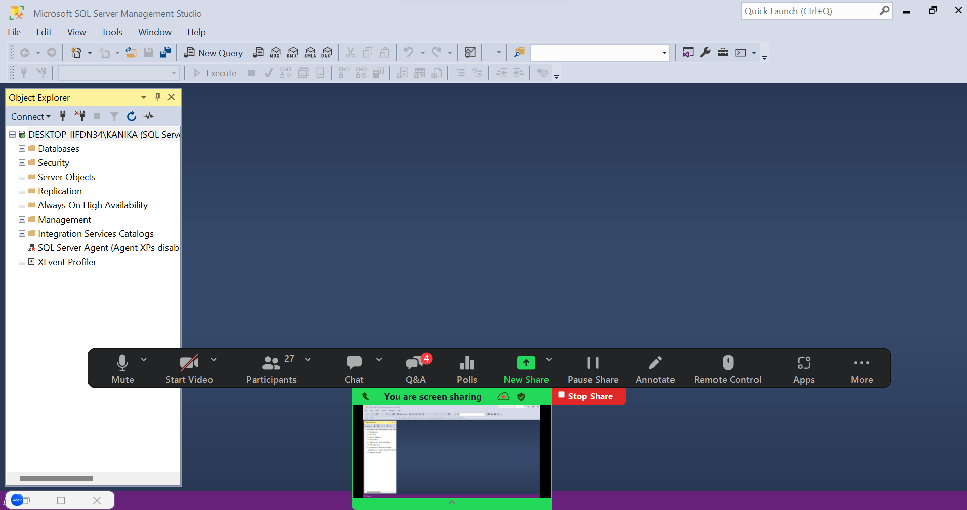

Steps:

Open the Microsoft official website for SQL downloads

Select developer mode and install it.

So in installation type choose custom and install it

In sql installation center go on installation and choose new sql server standalone installation

In sql server setup choose free edition for developer

Accept the license terms

Use microsoft update to check in install rules page we need to make sure that all the features are passed except windows firewall as warning

On azure extension page uncheck the “Azure extension for SQL server”

In in feature selection select database engine services and sql server replication

In instance configuration choose named instance and give a instance name

In server configuration make the SQL browser disabled to automatic

Finally in database engine configuration choose mixed mode and give the password confirm the password and select add current user.

On ready to install click on install

Install ssms from management tools

Once installation is completed open ssms and make the connection.

1. Give the difference between Char and Varchar data type.

Char is fixed length of datatype it will allocate the entire space even though when its not required or not in usage, it’s a static memory allocation. Slightly faster then varchar

Varchar is variable length of datatype it will allocate only the required memory, it is a dynamic memory allocation. Slightly slower then char.

1. Explain the types of SQL Commands

DDL: Data Defination Language:DDL is used to create or restucture the database objects.DDL is used to create new database tables, defining the columns, data types, constraints, and other attributes of the table.

Create, Alter , Drop(CAD commands)

Create command is used to create a structure like database or a table

Example: create database august20

Create table employee(employee_id int,employee_name varchar(30),salary int)

Alter: it is used make any changes or alter a record in a table

Alter table employee add designation varchar(30)

Drop:drop is used to drop the database or a table completely

Drop database database_name

Drop table table_name

DML: Data Manipulation Language : Dml is used to manipulate the data present in the database.

Insert, Update , Delete

Insert: this commands allows the users to insert the rows and columns into the table.

Insert into table_name values( value 1, value2.…………..)

Update: when any modification is required we can use update

UPDATE table_name SET column1 = new_value1, column2 = new_value2 WHERE condition;

Delete: delete from table_name where condition

DQL: Select -> retrieving the data

DCL: Data Control Language

Grant revoke

1. Explain NVarchar and Nchar

Nvarchar is used to store variable length unicode charcater data

(n’chinese language)

(n’ (*#%%)

Nchar is used to fixed length unicode character data